
ACTIVE LEARNING TEMPLATE: Growth and Development

STUDENT NAME

DEVELOPMENTAL STAGE Adolescent REVIEW MODULE CHAPTER

EXPECTED GROWTH AND DEVELOPMENT


Physical
Development

The anatomical developed should be monitored e.g. breast shape and the pelvic area anatomy in female. In male the retraction of the penis foreskin and the deepening of voice are expected. Growth in pubic hair will also be experienced as well as menstrual cycle in females begins.

Cognitive
Development

The cognitive developments at adolescents at his peak the adolescent has high think and reasoning capacity and can makes some decisions on her own. The adolescents should be able to understand the different between right and wrong and has the ability to choose either (King, 2007).
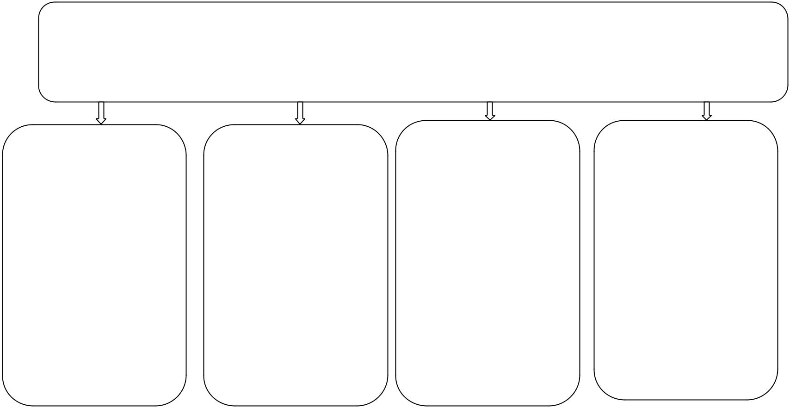

Psychological
Development

At this stage tends to exhibit some behaviors in orders to fit with their peers. They need to be watched closely because of the esteem problems.

An adolescent realizes their sex and gender roles at this stage and most of them shape their behaviors (King, 2007).

Age- Appropriate Activities

The appropriate activity for adolescents includes watching (limited), hiking, biking, playing in the fields and walking.

Health promotion

At these stage children suffers very many risk such as scoliosis, urinary refusal autism and attention deficit disorder among other problems. Mostly, it is appropriate to seek medical advice to help when the above indications have been observed (Snider, 2007).

Immunizations

From the 12 age children at adolescents are advised to be immunized against diseases such as chicken pox, mumps varicella virus.

Health Screening

Health screening among the adolescents it important becomes it helps identify disease that they be fatal if identified late .The screening may involve cervical screening, testicular screening, and cardiovascular diseases. Early detection of these diseases is recommended.

Nutrition

When it comes to nutrition the adolescents should be fed on foods which are high on starch. The period of life there is very high energy that is needed by adolescents due to high activity rate. Generally a balance diet should be maintained depending on the CDC recommendations.

Injury Prevention

The most common preventions for the adolescents is against sexual activities, drugs abuse and other unethical behaviors such as violent activities (Snider, 2007).

ACTIVE LEARNING TEMPLATES THERAPEUTIC PROCEDURE A5

